**Compass - MED D -** **Specialized Member Services Team (SMST) – Disenrollment Reasons Guide**

General Information

Reference Chart

Related Documents

**Description:** The document assists the Specialized Member Services Team (SMST) with locating the correct process or work instructions when a beneficiary has been disenrolled.

| General Information |
| --- |

When researching the reason why a beneficiary has been disenrolled, navigate to the Medicare D Landing Page - Eligibility & Plan tab, in the Enrollment Details section, refer to the **Disenrollment Reason** field.

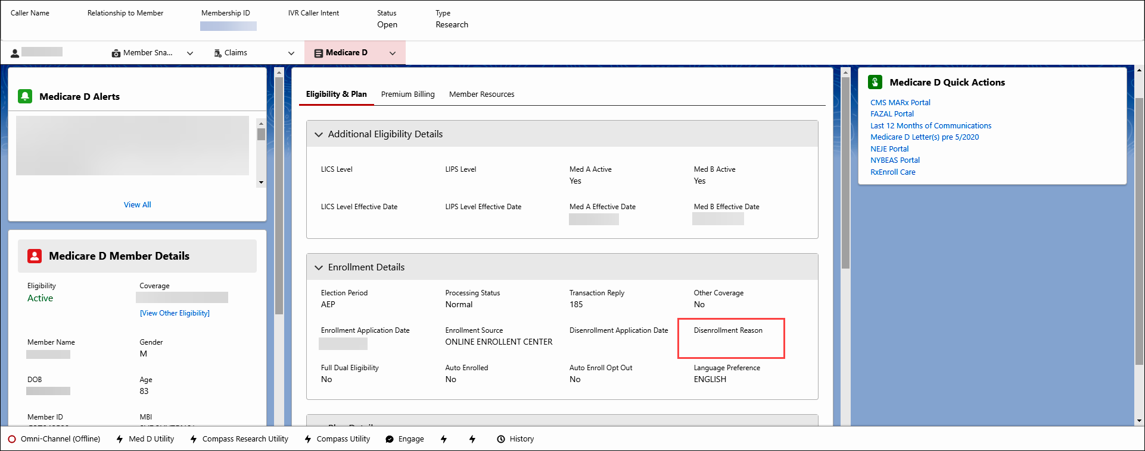

**Note:** The CCR should also reference the disenrollment letters in: **Last 12 months of Medicare D Communications**hyperlink in the **Medicare D Quick Actions** panel of the **Medicare D Landing Page;** all previous call notes in the **Member’s Recent Cases** panel;and **Member Snapshot Landing Page** and the**Medicare D Landing Page - Medicare D Alerts**section.

Top of the Document

| Reference Chart |
| --- |

The CCR will utilize the chart below to determine the correct work instruction by the Disenrollment Reason**:**

|  |  |  |
| --- | --- | --- |
| **Disenrollment Reason** | **Description** | **Work Instruction** |
| 1. **OUT OF AREA DISENROLLMENT** | Beneficiary has confirmed a change in residence outside their current service area/region and must be disenrolled. This includes moving out of the country. | [Compass MED D - Address Changes and Out of Area (OOA)](https://thesource.cvshealth.com/nuxeo/thesource/#!/view?docid=a5cf7af0-8a89-45dc-a395-9961dceac183).  [Compass MED D - RxEnroll Care Downtime Procedures - Address Changes and Out of Area (OOA)](https://thesource.cvshealth.com/nuxeo/thesource/#!/view?docid=f7cd8032-f520-448e-b45f-842b4a6cd07d). |
| 1. **INCARCERATED** | Beneficiary is confirmed to be in the custody of a penal authority and confined to a correctional facility, such as a jail or prison, or a mental health institution as a result of a criminal offense.  Such individuals reside outside of the service area for the purposes of Part D plan eligibility, even if the correctional facility is located within the plan’s service area. | [Compass MED D - Address Changes and Out of Area (OOA)](https://thesource.cvshealth.com/nuxeo/thesource/" \l "!/view?docid=a5cf7af0-8a89-45dc-a395-9961dceac183).  [Compass MED D - RxEnroll Care Downtime Procedures - Address Changes and Out of Area (OOA)](https://thesource.cvshealth.com/nuxeo/thesource/#!/view?docid=f7cd8032-f520-448e-b45f-842b4a6cd07d).  [Compass MED D - SilverScript and Blue MedicareRx (NEJE) - Resolving Eligibility Issues for Incarcerated or Not Lawfully Present Beneficiaries.](https://thesource.cvshealth.com/nuxeo/thesource/" \l "!/view?docid=8824428c-b769-4917-83bf-19549ec6f873) |
| 1. **UNLAWFULLY PRESENT** | Beneficiary is considered not lawfully present (not a US citizen). An individual who is not lawfully present in the United States is not eligible for any federal public benefit, including payment of Medicare benefits. | [Compass MED D - SilverScript and Blue MedicareRx (NEJE) - Resolving Eligibility Issues for Incarcerated or Not Lawfully Present Beneficiaries.](https://thesource.cvshealth.com/nuxeo/thesource/#!/view?docid=8824428c-b769-4917-83bf-19549ec6f873) |
| 1. **LOSS PART D ELIGIBILITY** | Beneficiary has lost entitlement/eligibility for Medicare benefits. This includes the loss of Part A, Part B, and or Part D. | [Compass - MED D - Specialized Member Services Team (SMST) - Mistaken Disenrollment](https://thesource.cvshealth.com/nuxeo/thesource/#!/view?docid=3b32462a-76c5-4b79-ad45-97996bc56a0f) |
| 1. **MEMB DECEASED** | Beneficiary has been reported deceased by the Social Security Administration (SSA) and Medicare as notified the plan. | [Compass MED D - Deceased Beneficiary.](https://thesource.cvshealth.com/nuxeo/thesource/#!/view?docid=03532634-0441-4503-8b66-d19f9eec0c32)  **Note**: If the caller (or beneficiary) states that the beneficiary is not deceased, refer to: [Compass - MED D - Specialized Member Services Team (SMST) - Mistaken Disenrollment](https://thesource.cvshealth.com/nuxeo/thesource/#!/view?docid=3b32462a-76c5-4b79-ad45-97996bc56a0f). |
| 1. **IRMAA DISENROLLMENT** | Beneficiary failed to pay Income Related Monthly Adjustment Amount (IRMAA) payments with their Part D premium. | [Compass MED D SilverScript - Process for Good Cause Determinations - For Non-payment of Part D-IRMAA](https://thesource.cvshealth.com/nuxeo/thesource/#!/view?docid=be7314b7-c0f7-4f6b-ada6-7e9267b1852b). |
| 1. **NON NEJE INV TERM**   OR  **INVOLUNT DISENROLL NO PAY PREM** | Beneficiary failed to pay premiums timely and was disenrolled through the dunning process. | [Aetna Compass MED D - SilverScript - Premium Billing Dunning and Disputes Process](https://thesource.cvshealth.com/nuxeo/thesource/#!/view?docid=9efb103a-cdee-4055-8fe2-870f7486feb4). |
| 1. **DISENROLL – NEW MCO** | Beneficiary was or will be disenrolled at a future date due to enrollment in another Part D plan. | [Compass MED D - Specialized Member Service Team (SMST) - Disenrollment Due to Enrolling in a Different Prescription Drug Plan (PDP)](https://thesource.cvshealth.com/nuxeo/thesource/#!/view?docid=f4d74454-3dea-4ce7-9c6a-fd40ae8a1563) |
| 1. **DISENROLL - NEW MMP** | Beneficiary will be disenrolled due to CMS enrolling the beneficiary into a Medicare Advantage: Medicare-Medicaid Plan (MMP). | [Compass MED D - CMS Passive Enrollment in MMP - Required Voluntary Disenrollment from the PDP, Opt-Out and Disenrollment from the MMP.](https://thesource.cvshealth.com/nuxeo/thesource/#!/view?docid=4d52d68c-a6f6-40c7-9c55-c3b3a710f451) |
| 1. **NOT ENROLLED** | The beneficiary is disenrolled from the Part D plan.  **Note:** This reason is associated with several different processes but is most often seen once a member has completed the Voluntary Disenrollment process. | To review the status of a disenrollment request**:**   * [Compass MED D - Specialized Member Services Team (SMST) - Voluntary Disenrollment](https://thesource.cvshealth.com/nuxeo/thesource/#!/view?docid=e26dafa6-215c-4edc-9452-9fb4c29233db)   If the beneficiary is disenrolled and wishes to enroll, advise the beneficiary that they must complete a new enrollment.  Warm Transfer to**:**  1-844-985-0085  **Internal Use Only**    Enter Caller’s Zip Code when prompted.    **Note:**Phone number to provide to the beneficiary**if requested** is 1-833-606-0372. Advise the caller not to select Option 1 as this will return the caller to SilverScript Customer Care. State there will be two selections to make and provide the appropriate Options to select for each call type below:   * **Current enrolled beneficiary:** Select Option 2 and then Option 1 * **Prospective (non-beneficiary):** Select Option 2 and then Option 2 |
| 1. **INVOL EGWP DSNRLL - ADV NTC**   Beneficiary will be disenrolled from current EGWP plan. |  | * Review the “**Last 12 months of Medicare Communications”** for any letters sent to the beneficiary. * Review the applicable CIF for additional information. |

Top of the Document

|  |
| --- |
| Related Documents |

* Grievance Standard Verbiage (for use in Discussion with Beneficiary) section in [Compass MED D - Grievances Index](https://thesource.cvshealth.com/nuxeo/thesource/#!/view?docid=70034f51-77df-49a4-ae97-7d3d63b216b3)
* [MED D Enrollment - FAZAL](https://thesource.cvshealth.com/nuxeo/thesource/#!/view?docid=db8c2342-e9e4-467b-8cd9-ccb712533400)
* [MED D - SHIP Counselor Calls for CVS Caremark Part D Plans](https://thesource.cvshealth.com/nuxeo/thesource/#!/view?docid=3f853166-b8d0-477c-8fae-9d6ab8ea98f1)
* [Compass MED D - Appointed Representative Form (AOR) or Power of Attorney (POA)](https://thesource.cvshealth.com/nuxeo/thesource/#!/view?docid=64c3fc62-48c3-4ad3-ae83-c736cebd521b)
* [Compass MED D - SilverScript and Blue MedicareRx (NEJE) - Enrollment Related Support Tasks](https://thesource.cvshealth.com/nuxeo/thesource/#!/view?docid=39a75bb6-425d-4eb7-a436-036f5da9d31a)
* [MED D - Election Periods for Enrollment and Disenrollment (AEP, IEP, SEP)](https://thesource.cvshealth.com/nuxeo/thesource/#!/view?docid=23d6bdd2-b914-4dd9-bf92-05f5d0f1088a)
* [Compass MED D - CMS Passive Enrollment in MMP - Required Voluntary Disenrollment from the PDP, Opt-Out and Disenrollment from the MMP](https://thesource.cvshealth.com/nuxeo/thesource/#!/view?docid=4d52d68c-a6f6-40c7-9c55-c3b3a710f451)

**Parent SOP:**

* MEDS-0041**:** [Medicare Part D Voluntary Disenrollment, CVS Caremark Part D Services, L.L.C., Policy and Procedure](https://policy.corp.cvscaremark.com/pnp/faces/DocRenderer?documentId=MEDS-0041)
* MEDS-0006**:** [Medicare Part D - Cancellation of Enrollment and Disenrollment Policy and Procedure, CVS Caremark Part D Services, L.L.C.](https://policy.corp.cvscaremark.com/pnp/faces/DocRenderer?documentId=MEDS-0006)
* CALL-0048**:** [Medicare Part D - Customer Care Call Center Requirements, CVS Caremark Part D Services, L.L.C.](https://policy.corp.cvscaremark.com/pnp/faces/DocRenderer?documentId=CALL-0048)

**Abbreviations/Definitions:**

* [Abbreviations / Definitions](https://aetnao365.sharepoint.com/sites/PolarisPHDDocumentationReview/Shared%20Documents/AppData/Local/Microsoft/AppData/Local/Microsoft/AppData/Local/Microsoft/Windows/INetCache/Content.Outlook/AppData/Local/Microsoft/Windows/INetCache/Content.Outlook/2ULSS2XL/CMS-2-017428)

Top of the Document

Not To Be Reproduced Or Disclosed to Others Without Prior Written Approval

**ELECTRONIC DATA = OFFICIAL VERSION – PAPER COPY = INFORMATIONAL ONLY**